ACS-2814: Applications Of Database Systems
Lab 5

Daljeet Singh, 3169763

Part A: Basic Table Create and SQL Commands [ 3 marks ]
Place screenshots of the key steps in the table below

Question/Step | Screenshot (paste below, adjacent to each question)
5. [3 marks] Take a screenshot of the data (be sure to include your visible table name as evidence of your work) and place it in the Lab submission template. | 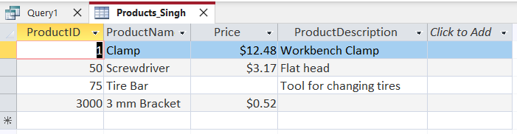

Part B: Updating and Select Query Basics [ 4 marks ]
Place screenshots of the key steps in the table below

Question/Step | Screenshot (paste below, adjacent to each question)
4. [2 marks] You should see a subset of the columns similar to the screenshot below.  Take a screenshot of the data (be sure to include your visible table name as evidence of your work) and place it in the Lab submission template. | 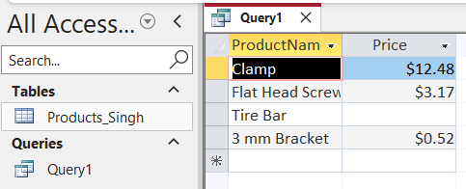
5 a) [1 mark] Query with Where Clause | 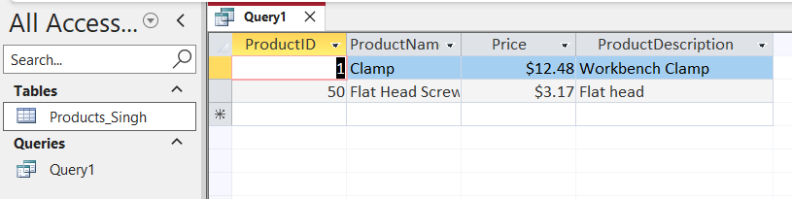
5 b) [1 mark] Query with an expression/calculation in the select. ….. | 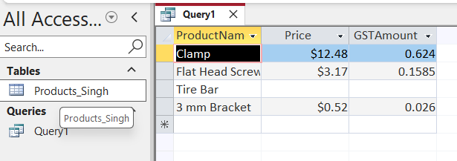

Part C: Aggregate Queries and Null Values [ 5 marks ]
Place screenshots of the key steps in the table below

Question/Step | Screenshot (paste below, adjacent to each question)
1a. [1 mark] Summarizing the value of products in the table using average. | 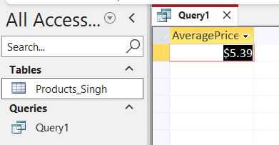
1b. [1 mark] Counting in the table with criteria. | 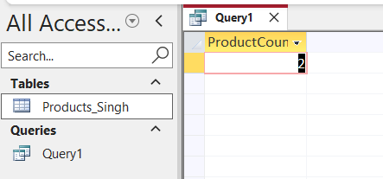
2b. [1 mark] Repeat the same query we did earlier to get the average. Notice that there is no change to the average. | 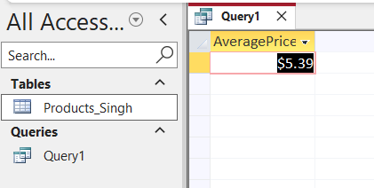
2c. [1 mark] Now we will experiment with null data specifically by issuing a count query with a filter. | 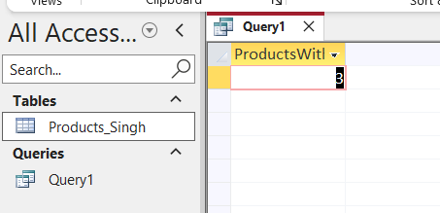
2d. [1 mark] Now instead of counting rows using the asterisk, we’ll see what count we get by counting a specific column. Do null values get counted? | 